PERMISSION SLIP for Victory Missionary Baptist Church – Russellville, AR
August 1, 2019 – August 31, 2020

PERMISSION/MEDICAL RELEASE FOR
Name: Phone:
Address: City: State: Zip:
Birthdate: School: Grade:
Parent/Guardian’s Name:
Visitor? Who invited you?
I give permission for my child to join the Youth of Victory Missionary Baptist Church of Russellville, AR, in any of the activities or trips sponsored by the church, its staff and sponsors. I hereby release them from responsibility and liability for any illness or injury that my child may sustain during this activity. In the event of an emergency, I hereby authorize an adult leader of this activity as agent for me, to consent to any x-ray examination, medical, dental, or surgical diagnosis, treatment, and hospital care advised and supervised by a physician, surgeon, dentist (as appropriate), licensed to practice under the laws of the state where services are rendered, either at a doctor’s office or in any hospital. I expect to be contacted as soon as possible.
This document will be valid and in full effect from August 1, 2019 – August 31, 2020
____________________________________________________________
Date Parent’s Signature
Emergency Phone Numbers: 1. 2.
Medical Information: (Required for ALL off-campus activities)
Allergies:
Medications being taken:
Physical handicaps:
Medical Insurance Co.:
Name of Policy Holder: Policy #: Group #:
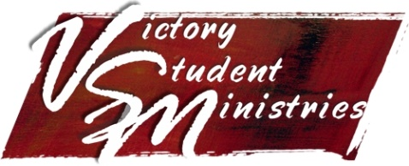
You will not be allowed to go on any youth trip off-campus with Victory Missionary Baptist Church without a permission slip signed by your parent/guardian on file.

